Toronto & Area Branch ON47
Minutes of Branch Annual General Meeting

May 5, 2026 @ 10:00AM via Zoom
1 | Welcome from the Chair  Dawn Effer welcomed everyone to the meeting. She serves as President and Treasurer (dual role); Natalie Migas is Vice-president but was absent due to a funeral. | Dawn Effer
2 | Technical Points for Zoom  Steve acknowledged that we had 27 members and 2 guest speakers on the Zoom call. He outlined the process for asking questions, voting on motions, for those on the Zoom and those on the phone. We will use the Chat function for all questions. | Steve Dunn
3 | Moment of Silence  Dawn called for a moment of silence for those who have passed since our last meeting, including Don Milne, longtime treasurer, who passed away in January 2026 and will be honoured with a tribute in the Summer Sage insert and has been nominated for a national award. | Dawn Effer
4 | Review Of October 14, 2025 Branch Annual Meeting (BAM) Minutes  Jim Molnar, our Past President chaired the October 14, 2025 meeting. Jim briefly reviewed the minutes of the 2024 AGM and made a motion that these be accepted, seconded by Steve Dunn, and carried by a majority of members present.  A review was made of the Financial Statements for 2024. The budget for 2025 was also shared and approved along with the Reserves.  Jim also indicated he was stepping back from the Board but will continue in an advisor role.  Elections:  President: Steve Dunn nominated Dawn Effer as President, Jim Molnar seconded. She agreed and her appointment was approved by a vote of the majority of members attending the meeting.  Vice-president: Jim Molnar nominated Natalie Migus as Vice-president, seconded by Dawn Effer. She agreed and her appointment was approved by a vote of the majority of members attending the meeting.  Treasurer: Dawn Effer has been working in the role of Treasurer since the beginning of 2025 awaiting ratification of the members at this BAM. As there were no other volunteers/nominations at this point, nominated by Jim and seconded by Steve. Her appointment to the role was approved by a vote of the majority of the members attending the meeting. She will continue to perform the functions until a replacement can be identified.  Secretary: There were no nominees/volunteers for this role. Steve Dunn has been doing much of the duties with support from the other Executive members. We will continue in this fashion until a replacement can be identified.  Advocacy Rep: Jim Molnar nominated Nicole Beaudry for this role, seconded by Steve. Nicole was unable to join the meeting today but indicated her willingness to take on this role. Her appointment to the role was approved by a vote of the majority of members attending the meeting.  Dawn noted that subsequent to this meeting, Nicole had gone back to work, so she has stepped away from this role.  A call out to the membership as a whole for volunteers to take on the Treasurer and Secretary roles will again be done through an e-blast. The members on the call were asked to consider volunteering or asking other members that they know personally to volunteer.  Guest Speaker  We had an excellent presentation by Lynn Nasralla from belairdirect – Travel Insurance who explained changes after transition from Johnson/MEDOC  Dawn made a motion to accept the minutes Steve seconded it and indicated with 27 members online we have our quorum. Motion was carried. | Dawn Effer
5 | President’s Report  - Since the branch has fully transitioned to virtual operations, the Board decided to close its physical office in July 2025 to reduce costs. All old documents were either shredded or will be scanned to be archived. The Branch, along with National Office, are looking at a solution for archiving electronic documents.  - We have been working hard to revitalize our branch, as many of our Board members a have left us because of health or other reasons.  - In March we held an online presentation with the CRA Outreach Team on tax benefit and credit programs for seniors.  - We are planning in the fall to have our first in-person meeting since before COVID and are hoping to increase the number of virtual and in-person information sharing meetings.  - We are using the National Office Preferred Partners for sources for past and upcoming presentations.  - The Branch has just signed a local Preferred Partnership with Park’N Fly.  - Ontario District Meeting in April was attended by Dawn and Natalie. There were many concerns raised with respect to new Proposed Governance structure. How would consolidation work and how the funding will be handled in the future in National Office takes over many duties. It was a first look and more info will be coming.  - Randall asked reasoning for the new proposed structure. Dawn explained this has been talked about and consulted over the past few years. Also, many branches like ours have problems getting volunteers for branch executive, with some branches having folded.  - Randall suggested we should set up Pub nights where we invite members and current federal employees to get together and share info and talk about issues. Also, we should be an info sharing hub for info for seniors that are available from other organizations. Randall is interested in assisting and Dawn has suggested a follow-up meeting with Randall, Steve and Natalie and herself to discuss.  - New National Website coming soon, it looks good and it is searchable. | Dawn Effer
6. | Treasurer’s Report  The financial position of our Branch for the period January 1 to December 31, 2025, are included below.  It was noted that the 2024 Financial Statements that were presented at our October 2025 Branch Annual General Meeting were restated after the National Office provided us with guidance for an adjustment for the discrepancies in the bank reconciliations balances for the 2024 and earlier years. We were intending to make this adjustment to our 2025 statements, but we were advised to reflect it in 2024 year.  Dawn quickly walked through 2025 Financial Statements, pointing out our Income is based on our share for fees allocated from National Office and we also have a $20,000 GIC. Our Expenses have decreased as we have closed out our physical office, phone and internet etc.  Excess surplus is the amount we are required to return to the National Office for their use for defense of our pensions and benefits. Overall, the Branch is in good financial position.  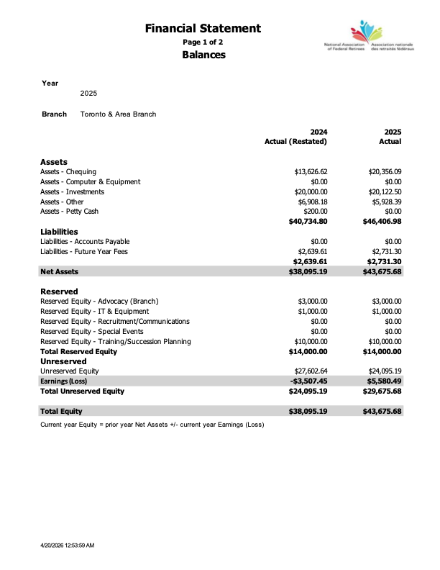  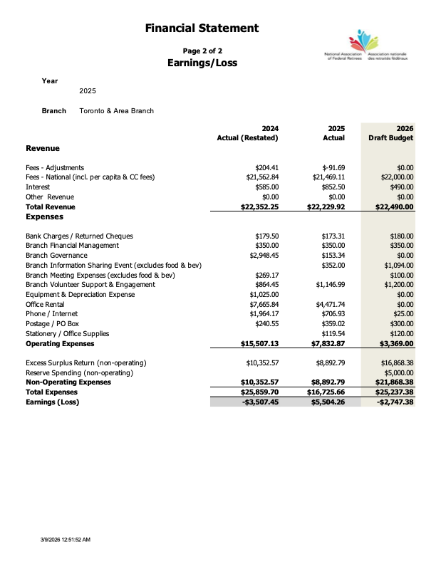  Dawn also presented the Draft 2026 Budget (included in the above Earnings/Loss statement). Income remains similar, but we are budgeting an increase in Excess Surplus as our expenses are much lower for 2025. We estimate in 2027 that we will be spending more on in-person functions and possible equipment purchases to meet our needs and possible advocacy work.  Dawn also presented the 2025 Reserves template showing total reserve of $14,000. This includes Advocacy Events/town hall for $3000; IT and Equipment purchase of $1,000, and Training and succession planning of $10,000.  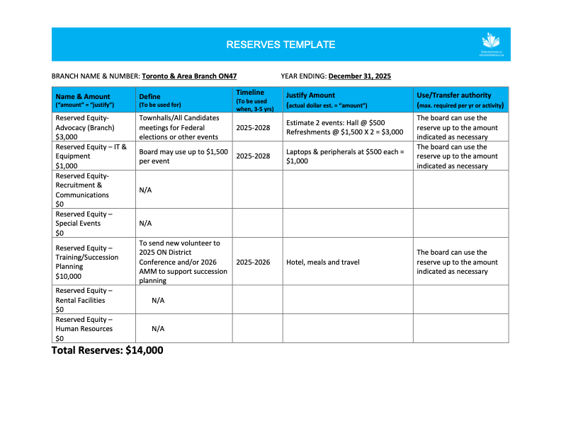  Dawn sent all of our supporting documents and bank statements to Arlene Smetaniuk for review. Arlene confirmed her findings to the members that everything was in good order and that she completed the required form for the National Office.  Dawn indicated that she has arranged for Catherine Tavaras from the Hamilton and Area Branch to take over the review as of 2026. We thanked Arlene for her excellent work for the past 4 years.  Motions:  - The 2025 Reserves Template totaling $14,000 was presented.  - The Financial Statements for the year ending 2025 showing earnings of $5,580.49 were presented.  - Dawn Effer presented a motion to approve the Budget for 2026, showing a loss of $2,747.38. The motion was seconded by Steve Dunn. Motion was carried.  - Dawn Effer presented a motion to appoint Catherine Tavaras as the financial reviewer for the year ending December 31, 2026. The motion was seconded by Steve Dunn. Motion was carried. | Dawn Effer
7 | Elections  Dawn asked if anyone is interested in volunteering to fill our Treasurer or Secretary positions. With no takers Dawn asked members to think about volunteering and contact the board to talk it over.  Advocacy Representative  Dawn indicated that Raimonds Peterson had shown interest in being our advocacy rep. She nominated him to be our advocacy rep for the Toronto and area branch. Steve seconded the nomination  Raimonds advised that unfortunately, he has health issues he can’t say he could take this on, but he would be interested in knowing what is involved.  Dawn indicated they could talk offline and since there is no one else interested at this time, we will revisit later. | Dawn Effer
8 | Membership And Recruiting  Jim Molnar was unable to be with us today, so Dawn mentioned that our Branch membership stands at approximately 2,400 members with 94% retention rate nationally.  With fewer pre-retirement courses offered at some of the government departments, the opportunity to do some recruiting is difficult.  We are asking our members to help recruit and remember you don’t have to be retired. Obviously, they are going to retire at some point, but they can still be members as well.  As previously mentioned, we will hold an in-person meeting in Oct and other possible social functions which will be recruitment opportunities.  Steve mentioned that we have a need for volunteers not just for the vacancies on the board but members to help with running our in-person meetings, other social functions and social media. | Dawn Effer
9 | Guest Speaker from NAFR National Office  Olga presented NAFR’s Advocacy priorities and how to get involved. The five priorities are retirement income security, reliable healthcare, positive and healthy aging, veteran well-being, and fairness for federal retirement.  Olga agreed to make her slide presentation available to all who are interested. | Olga Bindutiye
10 | Guest Speaker from new NAFR Preferred Partner Upper Canada Wills re Wills & Powers of Attorney  Unfortunately, technical issues prevented Arsalan from presenting, but he later recorded his presentation and has made it available for us to share with the members. We will also invite him to our in-person meeting in Oct, to discuss one-on-one with those interested. | Arsaln Zaidi
11 | New Business  Dawn shared some information on the new Local Preferred Partnership that we negotiated with Park’N Fly, discount rates, process for making a reservation, etc. We will make the information available to our members via Sage insert and on our website.  Steve shared new contact information in the Zoom chat and subsequently provided the new telephone number, which members can leave messages that will be responded by the Board.  (226-697-8011) for voicemail messages only | All
12 | Next Meeting October 20, 2026 – IN-PERSON  Details to follow, but there will be a light lunch, and as this is also a recruitment event, members are encouraged to bring potential members along with them.
13 | Adjournment at 12:15 with apologies from Steve for the technical issues.



