
A fall update from your Branch


EASTERN MANITOBA

We hope this update finds you well and enjoying life, whether that’s appreciating the wildlife out your window, visiting with those around you, doing puzzles, reading a book or just soaking up our Manitoba sunshine.
Fall General Meeting: On October 13 we held our Fall General Meeting. Once again, we were treated to the amazing soups, sandwiches and dainties from the Pinawa Alliance Church members. We received a very informative presentation from belairdirect on our Preferred Partners Travel Insurance. Please check it out if you travel within or outside of Canada - the coverage is fantastic. The Minutes from this meeting and an update on the Amalgamation Pilot Project are available on our Eastern Manitoba Branch webpage. While you are there, have a look around at our beautiful new branch and national webpages.
Amalgamation Pilot Project: We are working closely with the other three Manitoba branches and the National Office to initiate the Pilot Project to amalgamate Manitoba’s four branches into one Manitoba branch.
From our recent survey, we heard the following:
- While we do not want to eliminate in-person events, there is an appetite for online events. Doing so would allow us to connect with NAFR members outside of the current 4 main centres (Winnipeg, Brandon, Portage and Pinawa).
- Members are generally not well connected to their local branch and are comfortable with that.
- The most valued member services are not tied to your local branch.
What will the new structure look like?
- A direct tie to National Office
- An executive that resides throughout the province
- Communities of Practice with representatives throughout the province
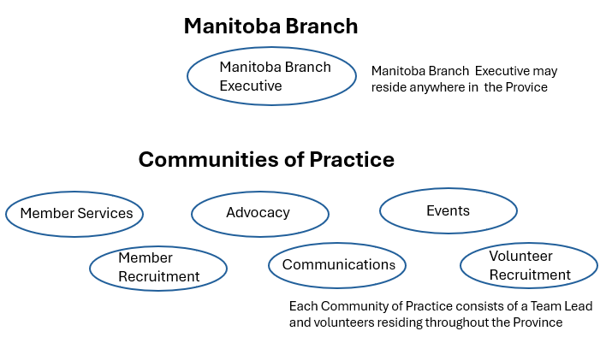
What is the timing of the pilot project? A vote will be held in December or January to gauge membership support. From there by-laws will be drafted and presented at the spring AGMs, along with the MB Branch Executive (formed from the current MB Branches’ executives) with a go live in May.
Events & Training Opportunities: On a separate note, we are excited to introduce Suzanne Houlind who has joined our team as our new Events Coordinator. She has already proven to be a great addition, planning what is promising to be a very fun event December 10 (stay tuned ) and looking ahead to 2027 to more opportunities with our members. Things are about to get fun and informative!
In the meantime, she came across a great website including courses for seniors. The site includes:

Courses are numerous and include the following topics. Please check it out and save it to your favourites – your next hobby or interest might be just around the corner.
- Technology skills training, from antivirus use to coding basics
- Health and nutrition, including yoga and healthy aging
- Tax and estate planning
- Arts and creative skills, from drawing to genealogy, storytelling and memoirs, crochet, digital painting
- Music appreciation and history courses
- Financial literacy and money management
- Environmental sustainability and gardening programs
- Free language learning options like Duolingo and university courses
- Universities in Canada offering free or discounted senior courses
Update on Travel Insurance: As an update to last year’s newsletter, we wanted to remind our snowbirds and other travellers of the following requirements from Manitoba Health, Canada Life and BelairDirect.
Federal retirees have limited out of country health coverage through Manitoba Health and, for those who have applied, coverage through Canada Life (MSH) and through BelairDirect (Global Excel)).
Manitoba Health requires that you are physically in Manitoba six months (183 days) in a calendar year to remain eligible for Manitoba Health coverage (Who is Eligible for Manitoba Health Coverage | Health | Province of Manitoba). Further guidance on possibly extending this coverage for up to seven months (212 days) can be found at the following link (Leaving Manitoba Temporarily | Health | Province of Manitoba).
Canada Life (MSH) has the 40 days no questions asked and $1M coverage policy, provided you are fit to travel. You must return to your province of residence to reset your coverage, and the 40 days include the day you left the province. There is no minimum time that must be spent in the province before departing again.
If you have the additional Belairdirect (Global Excel) Travel Insurance.
- If you are on the 40-day Base Plan, you can return anywhere in Canada to reset Belairdirect coverage. However, we recommend that members return to their home province to ensure the layering of coverage through different plans works seamlessly. Belairdirect is the second payer and will look to Canada Life (MSH) for the first $1M of coverage.
- If you have purchased supplemental coverage over the 40-day Base Plan, you must return to your home province to reset coverage. There is no minimum amount of time that must be spent in Canada before departing again.
Should you need assistance while travelling, please remember to call the number located on the back of your Canada Life (MSH) card or, if you are a subscriber, the Belairdirect card.
With all the things going on in the world it is always a good idea to check the most recent travel advisories Travel advice and advisories - Travel.gc.ca and register with Registration of Canadians Abroad service Registration of Canadians Abroad - travel.gc.ca when you are outside of Canada. Your travel insurance coverage may be impacted depending on the risk level of where you are going.
Membership: Membership dues support the Association’s ability to advocate on our priorities (Retirement Income Security, Positive & Healthy Aging, Reliable Health Care, Veteran well-being and Fairness for federal retirees). If you know of current or retired members of the federal public service, Canadian Armed Forces or RCMP, please encourage them to join, come to an event, or check out the Association’s website. Need a stepping stone? Have them sign up for free timely updates on Federal Retirees’ advocacy work, policy insights and resources that support better retirements and positive aging. Recipients will receive:
- Breaking news and advocacy highlights.
- Monthly e-newsletter with member perspectives and policy insights.
- Community stories and updates from across Canada.
- Access to select digital content like our quarterly e-magazine Sage60.
An apology: As a final note, we sincerely apologize to Ann Taylor, and to Peter & Sharon for our error in the In Memoriams section of the fall Sage magazine. We deeply regret any distress this may have caused.
Take care all. Wishing you peace, health and happiness.

Your Eastern Manitoba Branch Board:
Alanna Wilcox, President
Marg Stokes, Secretary
Bob McCamis, Treasurer, WebMaster
Karen Ross, Advocacy Liaison Officer, Health & Benefits Officer
Alice Young, Membership
Suzanne Houlind, Events

