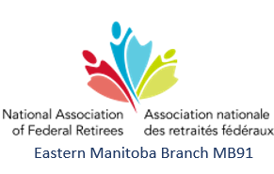
2026 October 13
Pinawa Alliance Church
Fall General Meeting - Minutes

Board Members Present
Alanna Wilcox – President
Marg Stokes – Secretary
Karen Ross – Health & Benefits Officer, Branch Advocacy Liaison
Alice Young – Membership Chair
Bob McCamis – Treasurer, Webmaster
Susanne Houlind - Events

Members and Guests Present
50 members for lunch and meeting
4 guests for lunch and meeting

- Call to Order
Alanna Wilcox called the meeting to order at 12:38 p.m.

- Introduction of Guests
- Winnipeg & area Branch President, Lionel Guerard
- Winnipeg & area Branch Vice-President, Don MacKay
- Central MB Branch President, Glen Jones
- Central MB Branch Director, Colin Wilcox

Although not a guest, I would like to take this opportunity to introduce our newest Board Member Suzanne Houlind who is our Chair of Events. Suzanne approached us this summer with an offer to plan events for our Branch. She is so enthusiastic and we are lucky to have her on board. Please welcome her.
- Approval of the 2026 October 13 Agenda for the Fall General Meeting (FGM) Attachment 1
MOTION to accept the 2026 October 13 Agenda for the Fall General Meeting (FGM).
Moved by George Montgomery and Seconded by Suzanne Houlind. Motion was carried

- Minutes of the 2026 April 23 Annual General Meeting (AGM)
MOTION that the minutes of the 2026 April 23 AGM of the Eastern Manitoba Branch be accepted.
Moved by Marg Stokes and Seconded by Karen Ross. Motion was carried

- Advocacy Update – Alanna Wilcox Attachment 2
Alanna gave an update on NAFR advocacy in the province.

- President’s Report – Alanna Wilcox Attachment 3
Alanna reported on the 2026 All Members Meeting All Members Meeting (AMM), District Meeting Sept 22/23, the Mega Recruitment Drive and the Federal Retirees Website.

Financial
Alanna presented the financial status as of 2026 Sept 30.

Events
A Christmas event is being planned for December.
Courses for Seniors – Suzanne came across a website (Free Online Courses for Seniors in Canada & Ontario) covering a wide range of topics, a link will be added to our NAFR webpage and in our upcoming newsletter.

Membership
531 active members including 8 new members, 3 members moved to a new branch, 7 members deceased.

Discussion: we need to let people know they do not need to be retired to join NAFR.

- Lynn Nasralla from belairdirect via Zoom
Lynn Nasralla gave a comprehensive presentation on travel insurance covered by belairdirect, including various scenarios and details of what is covered, what is not covered and how belairdirect wraps around our Public Service Healthcare Plan and Province of Manitoba coverage.

- Proposed Amalgamation of the Manitoba Branches Attachment 4
Alanna presented the pilot project for amalgamation of the Manitoba branches. We work very well together and started this conversation over a year ago.

- In Memoriam
At this time, I would ask that we take a moment to think of our friends and members who have passed away since our last meeting.
Judy Platford Ed Veronneau
Roy Taylor John Stefaniuk
Arlington Corbett

We do sincerely apologize to Ann Taylor, and to Peter & Sharon, for our error in the fall Sage magazine.

- Date for the 2026 AGM: April 2026, to be determined
- Adjournment
MOTION: at 1:53 p.m. that the 2026 October 13 Fall General Meeting (FGM) of the Eastern Manitoba Branch be adjourned.
Moved by Suzanne Houlind and Seconded by Paul Thompson. Motion was carried

Minutes Approved: _______________________________(date)

______________________________________ ____________________________________
President Secretary

SUMMARY OF MOTIONS

MOTION to accept the 2026 October 13 Agenda for the Fall General Meeting (FGM).
Moved by George Montgomery and Seconded by Suzanne Houlind. Motion was carried

MOTION that the minutes of the 2026 April 23 AGM of the Eastern Manitoba Branch be accepted.
Moved by Marg Stokes and Seconded by Karen Ross. Motion was carried

MOTION: at 1:53 p.m. that the 2026 October 13 Fall General Meeting (FGM) of the Eastern Manitoba Branch be adjourned.
Moved by Suzanne Houlind and Seconded by Paul Thompson. Motion was carried

Attachment 1
Branch Fall General Meeting - Agenda

October 13, 2026
Pinawa Alliance Church

- Call to Order
- Introduction of Guests
- Approval of the Agenda
- Approval of the Minutes of the 2026 April 23 Annual General Meeting
- Advocacy Update
- President’s Report
- Proposed Amalgamation of the Manitoba Branches
- In Memoriam
- Date for 2026 AGM: to be determined
- Adjournment

Advocacy Update – Alanna Wilcox Attachment 2

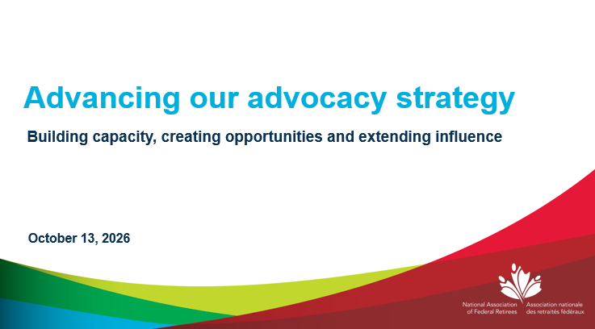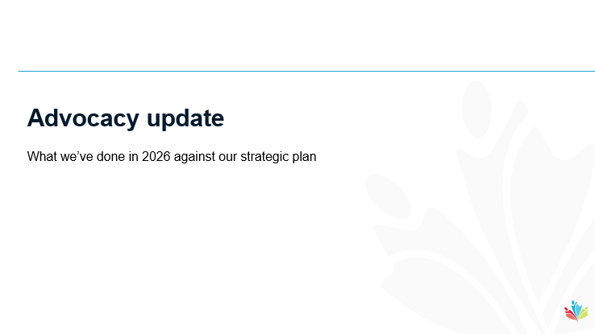

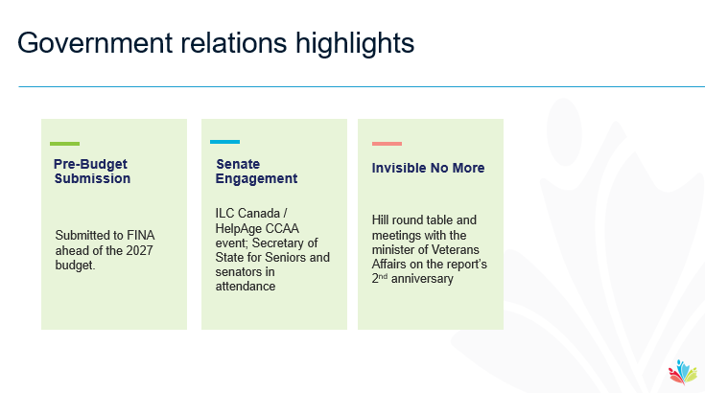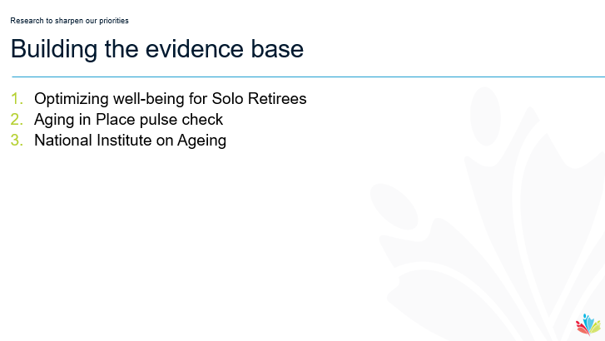

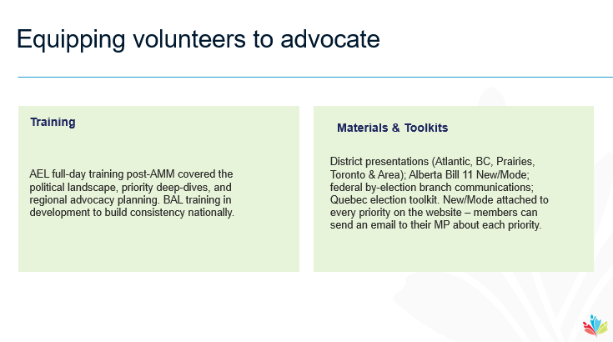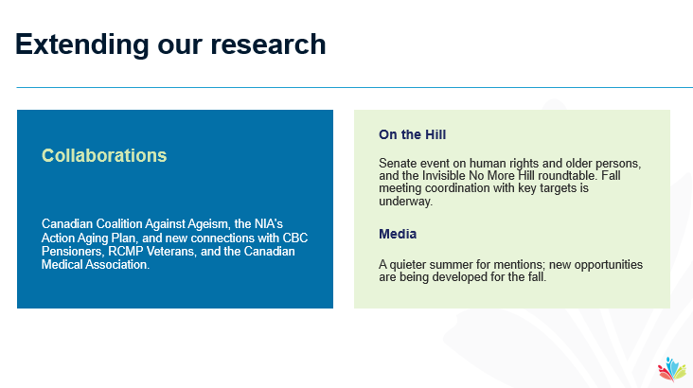

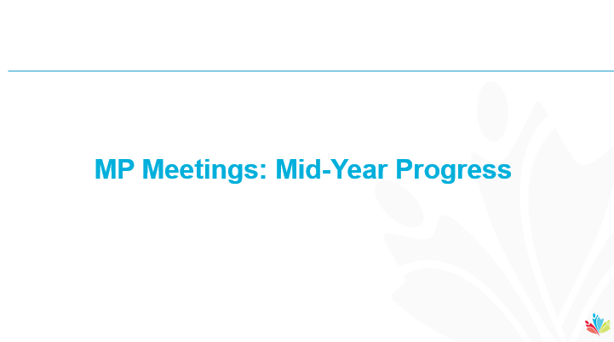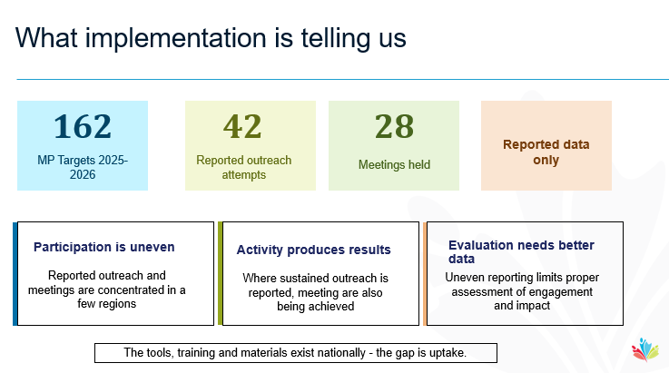



President’s Report – Alanna Wilcox Attachment 3

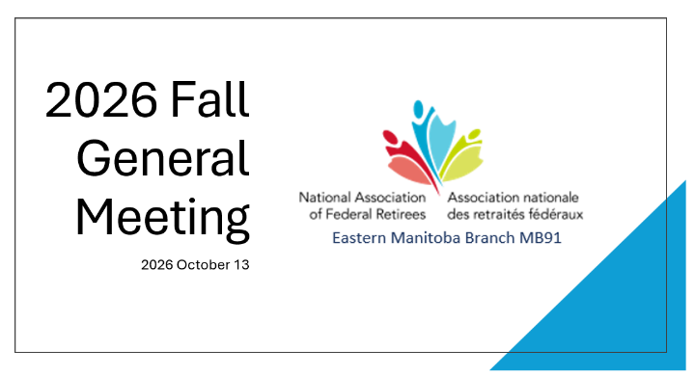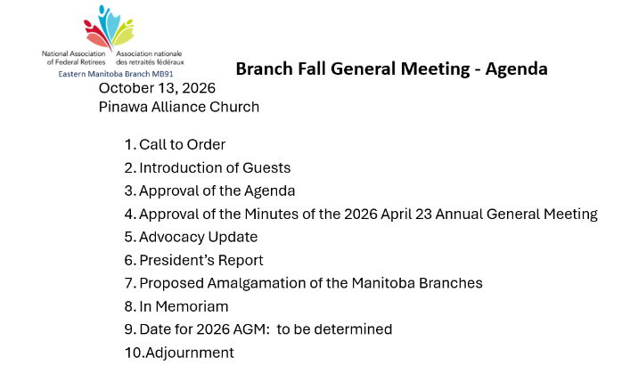

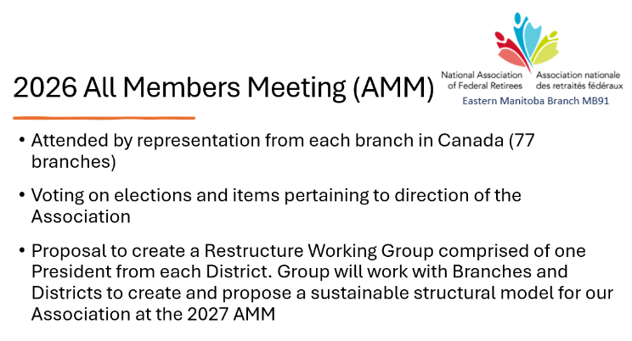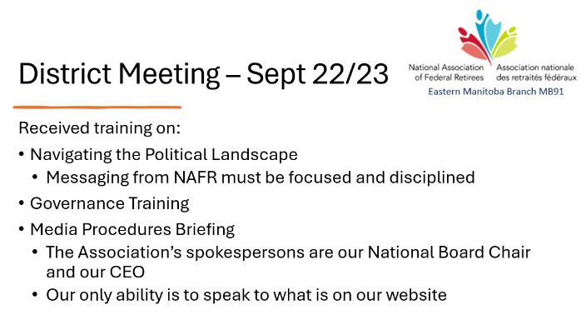

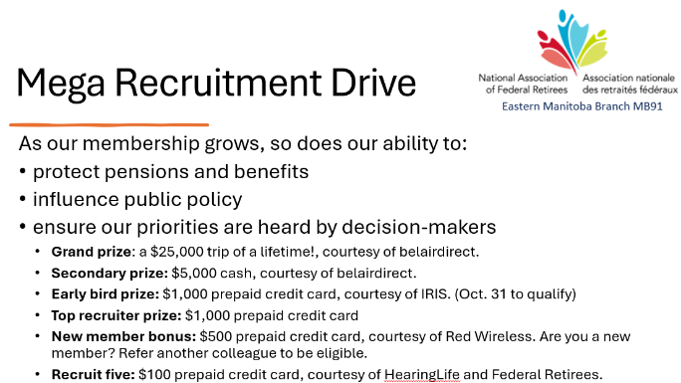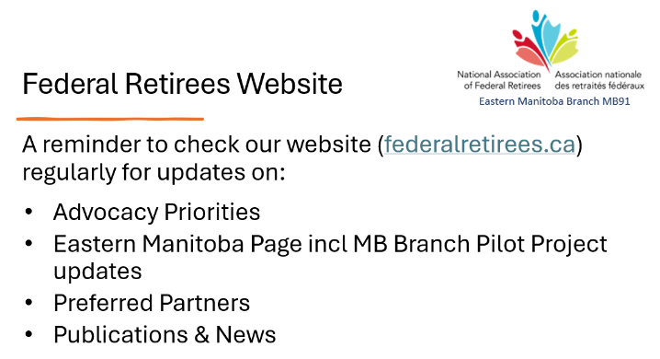

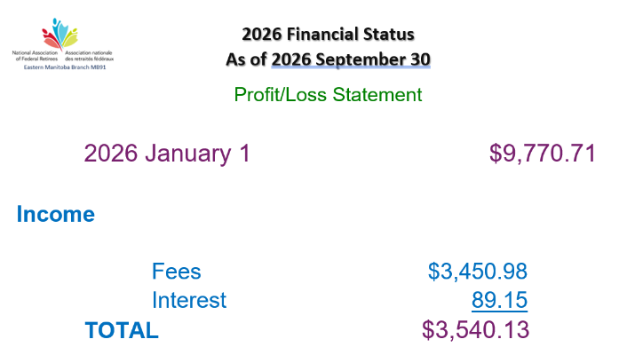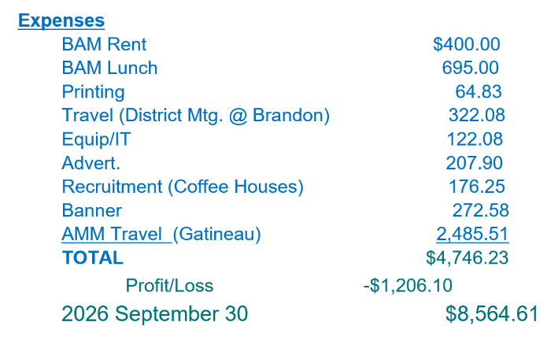

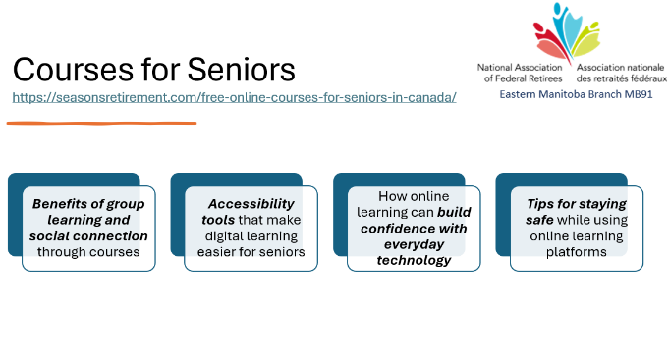

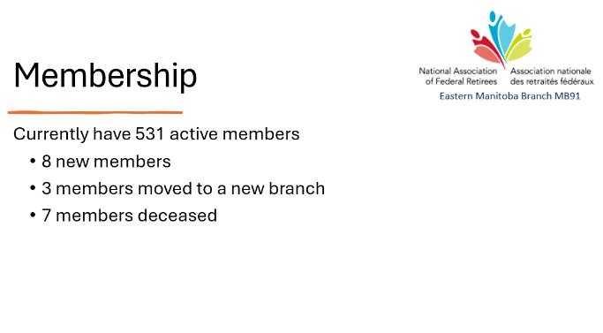



Proposed Amalgamation of the Manitoba Branches – Alanna WIlcox Attachment 4

