Activity Response Form

Kingston & District Branch – NAFR – Brockville Lunch
Tuesday – 16 June 2020 – 11:30 a.m. – Lunch at 12:30

Brockville Convention Centre
7829 Kent Blvd, Brockville, Ontario K6V 6N7
(Located across from the Holiday Inn Express and Suites)
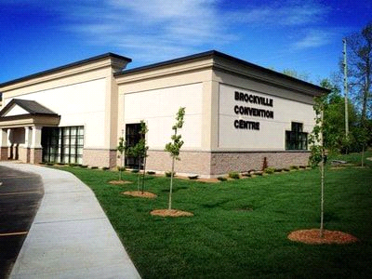
For further information contact: 613-542-9832 – toll free 1-866-729-3762 or www.federalretirees.ca/en/Branches/Ontario/Kingston-and-District
****************
Please Reply Prior to 1 June 2020
Reserve _______ places $10.00 per person
Cheque enclosed in the amount of $.............................................($10.00 person)
Make cheque payable to NAFR, ON38 – Cheques will NOT be cashed until after the event
Name(s) ___________________________________________________________________
Telephone ____________________ email _______________________________________
Mail to: Brockville Luncheon P.O. Box 1172, KINGSTON, ON K7L 4Y8

