BRANCH REPORT

ON35 | HURONIA

President’s message
As your newly elected President, it is my honour and pleasure to offer
greetings to all our members of Huronia Branch.

We continue to maintain a relatively large number of 1510 members and continue to try and grow our membership. Unlike gaining new members we have a greater challenge to get members volunteering to support certain Huronia activities or to join our Board. As a result, the size of our Board has dropped from 6 to the minimal number required to run a board which is 3. We have a President, a Treasurer and a Web Editor and cover the Board positions of Advocacy, Recruitment, Secretary, and Communication.

By the time you have read this we will have conducted a Meet and Greet Event at the WASAGA Legion for the purpose of reaching out to members further afield from the Wasaga Beach, Collingwood and Stayner communities and plan to reach out to members in other communities as our Branch area of responsibility includes 6 federal/provincial electoral ridings. For any information you would like to see presented or published please send us an email to huronia@federalretirees.ca.

Our Branch Board Members are here to assist you in any way we can, and it is a strong board with volunteers that can support our members more effectively so I encourage you to get involved in any way you can to help us support our membership.

Contact Us
80 Bradford Street
Barrie, Ontario
L4N 6S7
1-905-806-1954

huronia@federalretirees.ca
Huronia Federal Retirees

Membership
Effective January 1, 2025, single memberships are $57.24 per year and double memberships are $74.40 per year. Monthly deduction at source will be $4.77 for single membership and $6.20 for double membership.

Members are encouraged to pay membership dues through Dues Deduction at Source (DDS). It is the simplest and most convenient way to pay for your membership and to automatically renew annually. Thanks to our relationship with Treasury Board and the Pension Centre, the DDS option allows your membership fees to be deducted directly from your pension on a monthly basis.

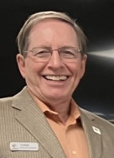

Sincerely,

Leo Brooks
Huronia Branch President



Huronia Branch Annual Members Meeting – May 1, 2025
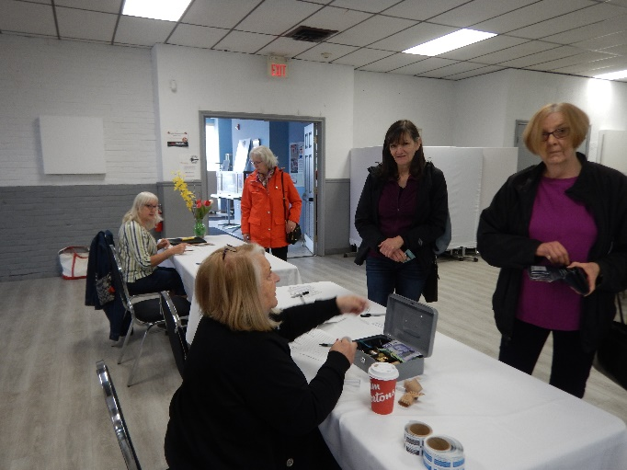
The Huronia Annual Members Meeting (AMM) was held at the Barrie Legion on May 1, 2025.
The meeting began with the President’s Report providing a brief summary of the activities by our Branch since our last meeting and the recent Ontario District meeting which he had just attended. The financial report for FY2024 and the new FY2025 were presented by Julia Nicholls, our Treasurer. It was followed by our Branch members approving 4 proposed amendments to our Branch By-laws.
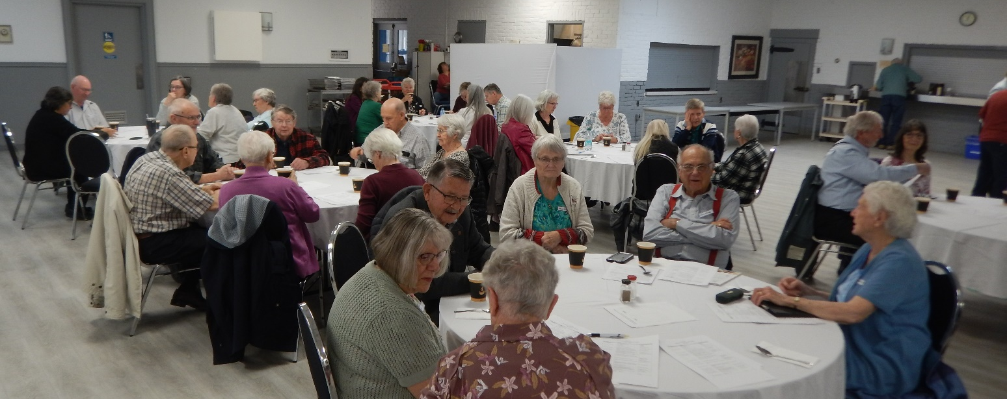
Four of our Board members did not run for re-election. After a run of 15 years, Noreen Campbell resigned in December 2024 as Treasurer. Kathy Rupnow resigned after having served on the Board for ten years. Mark Burchell did not seek re-election after 4 years on the Board as Communication Director. Finally, Manon Auger resigned after serving one year on the Board but agreed to continue to serve as a volunteer.
We have three re-elected members on the Board. Leo Brooks as the new President and continuing as Director Advocacy, Julia Nicholls, as Treasurer and Chris Auger, Director, Web Content Editor and assuming the responsibilities of Secretary, Recruitment and Communication until these positions can be filled.
Guest speaker Maren Drisch, addressing the attendees at the Huronia Branch AMM.
As the President pointed out in his message, because of the above elections, we are at a minimum number required to run a board which is 3. It is becoming critical to the sustainability of the Branch, that other Branch members join the Board. Monthly Board meetings are zoom meetings, so the only required travel is to the spring Branch AMM and Fall AGM, both held in Barrie. If you would like more information on the roles and responsibilities of each position, please contact us at huronia@federalretirees.ca.
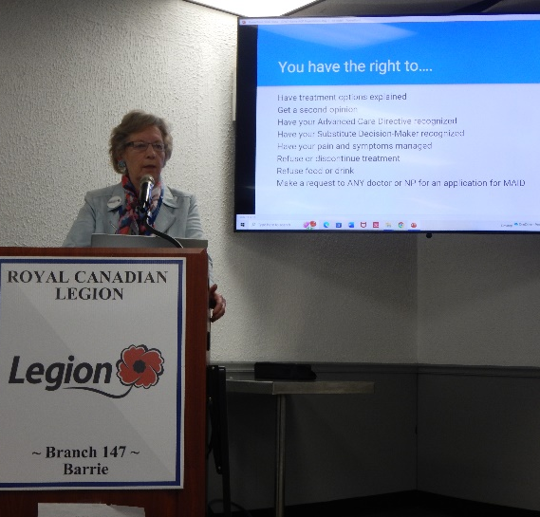
A highlight of the meeting was the presentation by the Barrie and Simcoe County Chapter member of Dying With Dignity Canada (DWDC) given by our guest speaker, Margaret Ringland (long-term association director / former RN) who presented an information session on Advance Care Planning (ACP). The session covered the What, Why and When to Create your own ACP, and how to select the right substitute decision-maker (SDM). The second part of this session will be presented by Dr. Brian Morris, MAID Practitioner, Barrie area at our Branch Annual General Meeting on October 8, 2025. You do not want to miss this session.

My Transition Seminar – CFB Borden on May 28, 2025
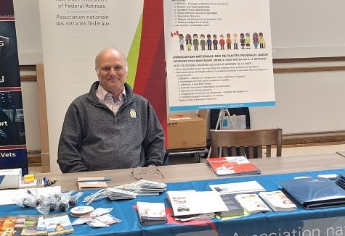
Chris Auger, Director Web Content Editor attended the networking fair portion of the My Transition Seminar at CFB Borden. This event was open to all members (civilians and military) of Base Borden to attend. Several people took away information about becoming members. Chris also met existing members of the Association. There was more interest this year then last year. Thanks to Chris for representing Huronia Branch.

Meet and Greet – Wasaga Beach on June 10, 2025

The Executive of the Huronia Branch was delighted to hold a Meet and Greet at the Wasaga Legion on Tuesday, June 10, 2025. The purposes of this event were both to give current members in the area the opportunity to meet their Branch Board members in-person and to recruit new members to join the Branch and perhaps as a Volunteer or Branch Board Member.

The event was attended by nine members and three Board members. There were members who had attended the Meet and Greet in Collingwood in attendance. The Board was attentive and paid attention to any suggestions by the members. Coffee, tea, muffins, and donuts were served and enjoyed by all.

Pamela Bacchus brought a non-member guest and qualified as our door prize winner of a $25 gift card for Winners! Congratulations Pamela!
Upcoming events
Event(s) name
Huronia Branch AGM
Wed, Oct 8, 2025
Doors open at 10:00 a.m. Meeting 11 a.m. until 1 p.m.

Royal Canadian Legion, 410 St. Vincent Street, Barrie, Ontario

Lunch: $10.00 for members and
$15.00 for non-members
RSVP to confirm at:
huronia@federalretirees.ca

Guest Speakers: Dr. Brian Morris, Medical Assistance in Dying (MAID) Practitioner, Barrie area. The presentation will address Medical Assistance in Dying and will cover How/When MAID became legal in Canada, MAID eligibility and process, and the anticipated change to the current MAID legislation.


President: Leo Brooks
Leo.brooks@rogers.com
Vice President: Vacant
Secretary: Vacant
Treasurer: Julia Nicholls
nichollsjuliaa@gmail.com
Advocacy: Leo Brooks (contact)
leo.brooks@rogers.com
Communications: Vacant

Web Editor: Chris Auger
cauger291@gmail.com

Recruitment: Vacant

Contact us
huronia@federalretirees.ca
Huronia Federal Retirees

Volunteers:
Dianne Michals – Reception
Jackie Akeson - Reception
Manon Auger – General
Peter Evans – Branch Fin Reviewer

Phone Callers:
Allen Atwell, Harry Austen, Marlene Brinklow, Wally Capsticks, Peter Evans, Joan Gauthier, Vic Lefaive, Bev Murphy, Monika Sargeant, Donna Wallace, Susan Wehling.

Thank you all for your service.
National association of federal retirees

Board and Volunteer Listings
2025-2026

