BRANCH REPORT

ON35 | HURONIA

Vice-President’s message
Greetings. Hopefully the worst of winter is behind us and we can look forward to longer and brighter days.

There are a number of personnel changes to the Board that I would like to announce. Chris Auger has stepped down as President effective December 31, 2024 and I, as Vice-President, will assume the responsibilities of the President until our May AMM. Chris has taken on the role of Secretary and remains our Web Editor. Julia Nicholls has assumed the role of Branch Treasurer. Noreen Campbell, after 15 years of service, the last 5 years as Treasurer, has resigned from the Board effective December 2024. As well, after 10 years, Kathy Rupnow will be resigning from the Board at the May AMM. We thank Noreen and Kathy for their many years of dedicated service. We are looking for volunteers to fill the roles of Recruitment and Director at Large.

Last year we had two well attended meetings at the Barrie Legion.
This year, I am very excited to announce that the Barrie and Simcoe County Chapter of Dying with Dignity Canada will be making presentations at our 2025 Annual Meeting of Members (AMM) and Annual General Meeting (AGM). At the May 1st AMM, the topic will be Advance Care Planning (ACP) and at our October 8 AGM, the topic will be Medical Assistance in Dying (MAID).

I am excited to announce a Meet and Greet later this year. The location will likely be Wasaga Beach but date tbd.

Your Branch Board remains committed to our membership.

Contact Us
80 Bradford Street
Barrie, Ontario
L4N 6S7
1-905-806-1954

huronia@federalretirees.ca
Huronia Federal Retirees

Membership
Effective January 1, 2025, single memberships are $57.24 per year and double memberships are $74.40 per year. Monthly deduction at source will be $4.77 for single membership and $6.20 for double membership.

Members are encouraged to pay membership dues through Dues Deduction at Source (DDS). It is the simplest and most convenient way to pay for your membership and to automatically renew annually. Thanks to our relationship with Treasury Board and the Pension Centre, the DDS option allows your membership fees to be deducted directly from your pension on a monthly basis.

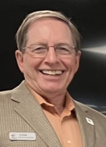

Sincerely,

Leo Brooks
Huronia Branch Vice-President


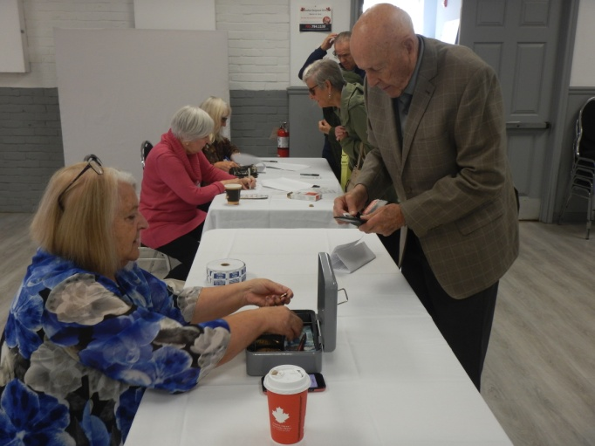

Huronia Branch Annual General Meeting – Oct 9, 2024
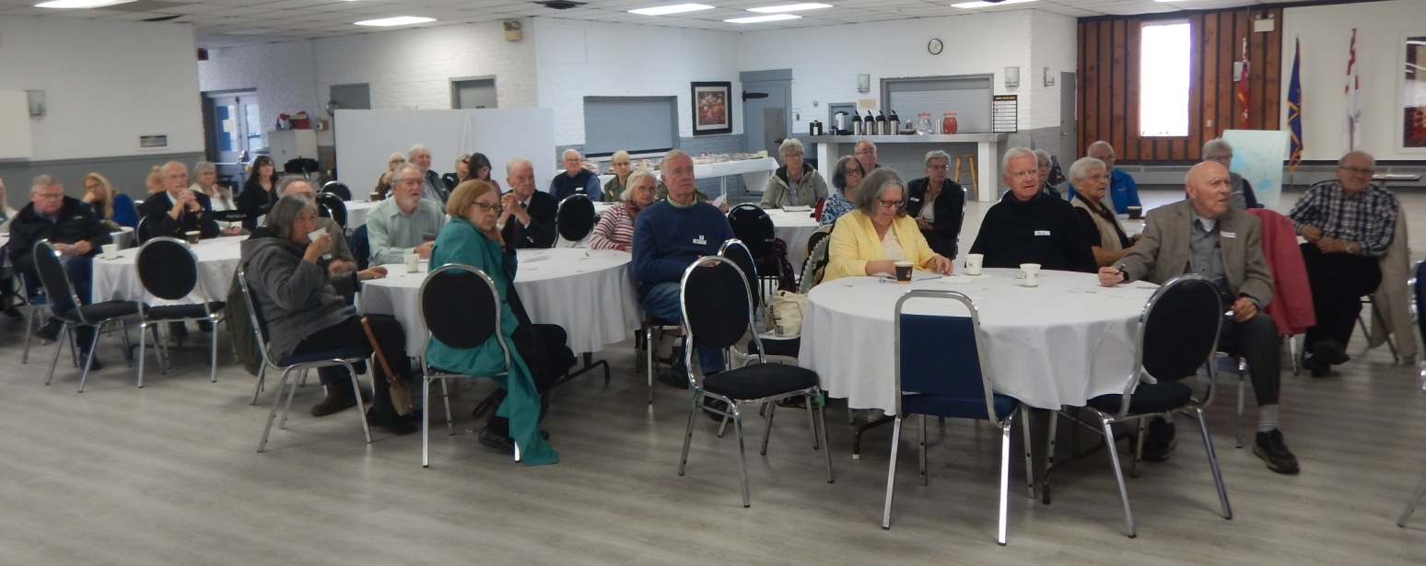
The Huronia Branch Annual General Meeting (AGM) was held at the Barrie Legion on October 9, 2024. A highlight of the meeting was the presentation given by the two guest speakers, Nina Cabral and Jeremy Bertrand from the Ontario Ministry of Finance who gave a very informative and entertaining presentation on Ontario’s Medical Expense and Senior’s Care at Home Tax Credit.

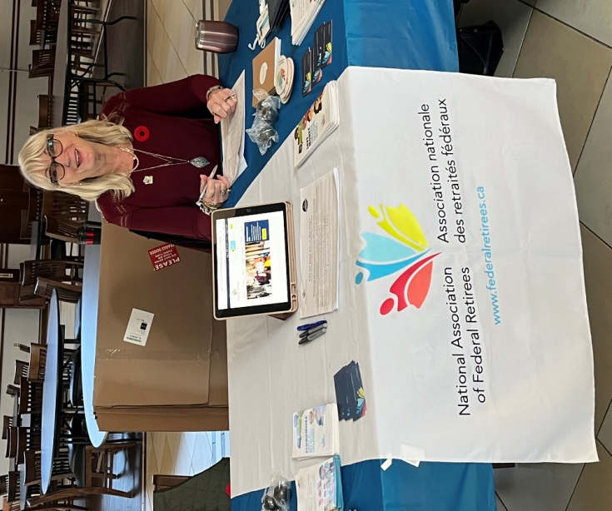
My Transition Seminar at CFB Borden – November 7, 2024
Noreen Campbell (Treasurer) and volunteer Diane Michals (former Secretary) attended the networking fair portion of the My Transition Seminar at CFB Borden. This event was open to all members of Base Borden to attend. A number of people signed up for our newsletter and took away information about becoming members. Thanks to Noreen and Diane for representing Huronia Branch.
Guest speaker Maren Drisch, addressing the attendees at the Huronia Branch AMM.

Dying With Dignity Canada (DWDC)

The Barrie and Simcoe County Chapter of DWDC will be providing two information presentations at our 2025 AMM and AGM to make you aware of your rights so that you feel empowered to make the best end-of-life choices for yourself. At the May 1, 2025 AMM, the presentation will cover Advance Care Planning (ACP) and will address the What, Why, When and How of ACP; How to select a substitute decision-maker (SDM); and the Process and Resources for creating an ACP. ACP should be done when one is healthy and able to reflect upon their values and quality of life, and therefore should be in place long before one has to make a decision about Medical Assistance in Dying. The speakers will be Cara Spearin (paramedic/death doula) and Margaret Ringland (long-term association director/former RN).

At the October 8, 2025 AGM, the presentation will address Medical Assistance in Dying (MAID) and will cover How/when MAID became legal in Canada; MAID eligibility and process; Anticipated changes to the current MAID legislation. The speaker will be Dr. Morris.

Advocacy – Reach 338

The National Association of Federal Retirees is building a nationwide network of advocates to advance our mission – to significantly improve the quality and security of retirement for our members and all Canadians. The network is called Reach 338, because our goal is to ensure that our advocacy work reaches all 338 federal ridings. Although the Huronia Branch geographical area covers six federal ridings, we focus our efforts on the following five: Parry Sound – Muskoka, Barrie – Innisfil, Simcoe – Grey, Barrie – Springwater – Oro – Medonte, and Simcoe North. National Office has produced a Training, toolkits and templates package, available for download, to assist all Reach 338 volunteers. More information is available at this link:
https://www.federalretirees.ca/en/advocacy/advocay-in-action/reach-338

With a Federal election likely in the very near future, your Branch Board is looking for Branch members who would like to be part of the Reach 338 network. Ideally we would like at least one volunteer from each riding who would be willing to meet with their local MP and the candidates from the other two major parties. Where possible, you could be accompanied by a Branch Board member. For more information, or to express interest, please contact Director of Advocacy, Leo Brooks by email at: leo.brooks@rogers.com

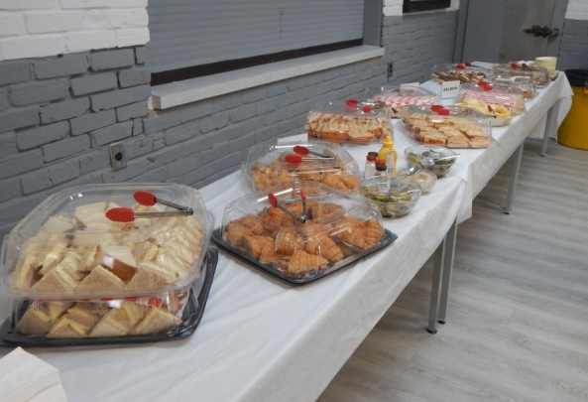
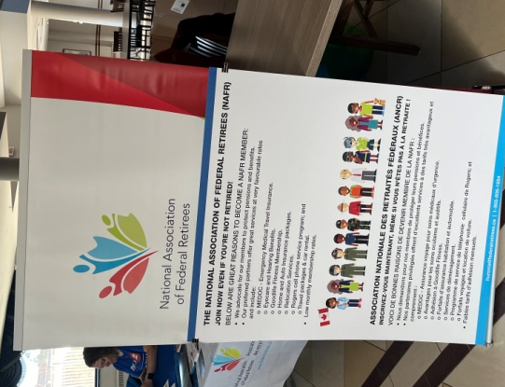
At left. Typical lunch spread put on by the Legion at our meetings.

At right. NAFR banner and poster at the My Transition Seminar at Base Borden.
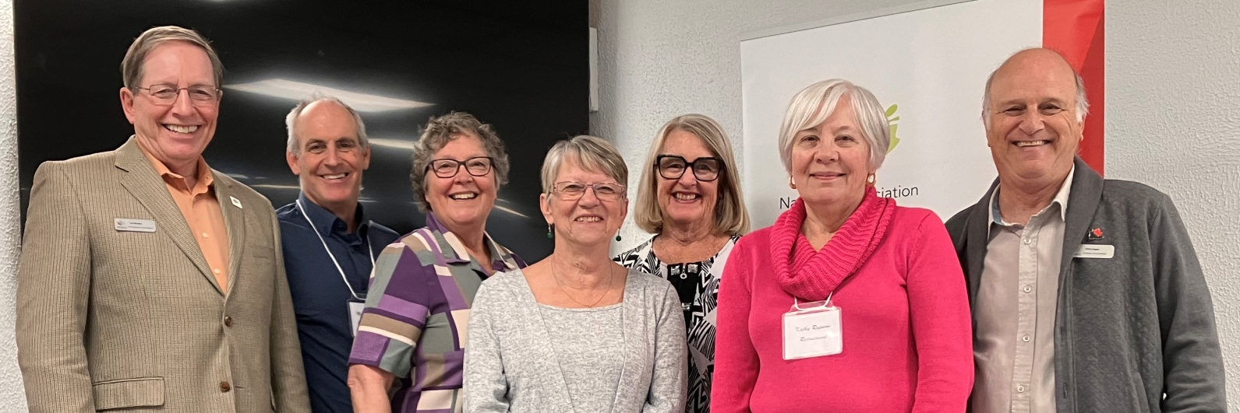
President: Vacant

Vice-President: Leo Brooks
leo.brooks@rogers.com

Secretary: Chris Auger
cauger291@gmail.com

Treasurer: Julia Nicholls
nichollsjuliaa@gmail.com

Advocacy: Leo Brooks
leo.brooks@rogers.com

National association of federal retirees

Board and Volunteer Listings
2024-2025
Huronia Branch Board members at the October 9, 2024 AMM: Leo Brooks , Mark Burchell, Julia Nicholls, Manon Auger, Noreen Campbell, Kathy Rupnow and Chris Auger.
Contact us
huronia@federalretirees.ca
Huronia Federal Retirees

Communications: Mark Burchell
mark_burchell@sympatico.ca

Web Editor: Chris Auger
cauger291@gmail.com

Recruitment: Kathy Rupnow
on35.recruitment@gmail.com

Director at Large: Manon Auger
augerm201@gmail.com

Upcoming events
Huronia Branch AMM
Thursday, May 1, 2025

Doors open at 10:30 a.m. Meeting 11 a.m. until 1 p.m.

Royal Canadian Legion, 410 St. Vincent Street, Barrie, Ontario

$7 for lunch
RSVP to confirm attendance and lunch:
huronia@federalretirees.ca

Guest Speakers: Cara Spearing and Margaret Ringland from Dying with Dignity Canada, Barrie and Simcoe County Chapter

Topic: Advance Care Planning (ACP)

