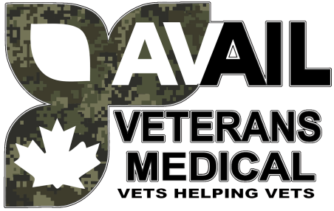

**Calling All Veterans…**

**What is Avail Veterans Medical Clinic:**

 Avail Veterans Medical provides medical services and medical assistive devices for retired female and male Veterans, First Responders and RCMP service personnel.

**Avail Veterans Medical is owned and operated by a Veteran.**

**Need a medical assistive device(s)** **for activities of daily living ?** We are a service provider of canes, tens machines, compression stockings, grab bars, medical beds, restorative health medical aids etc. All at no cost to you.

**Need access to a Physician?** We have our own Physicians who assist with pain management for healthy restorative pain management modalities and can write prescriptions and referrals to access these tools.

**Need an appointment with a Massage Therapist?** We have our own RMT on site to assist you with your massage needs.

**Need an appointment with a professional mental health counsellor?** We have our own, who specializes in healing your life by healing your memories and we can get you seen and heard.

**Need assistance with (VAC) paperwork/claims?** There are no charges or fees for this service and we take NO fees for any awards you may receive. Other companies charge fees or take a percentage of your award, we do not.

**Not sure what you are entitled to? Contact us today, we can help.**

Office Hours: Monday-Friday 9 am – 3 pm 20 Joseph Street Unit 4 Trenton.

Live out of town? Just call or email us and you can still access these services.

Email: [availveteranstrenton@gmail.com](mailto:availveteranstrenton@gmail.com) Office Phone:613-394-9002 Cell : 343-645-3508

**PLEASE NOTE: THERE ARE NO CHARGES FOR THESE SERVICES**