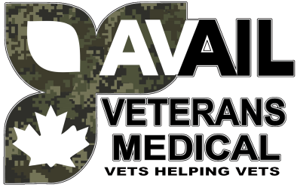

**VETERANS HELPING VETERANS**

In 2022, Avail Veterans Medical was born when four Fredericton NB-based Veterans got together to build a company to assist our Veteran sisters and brothers across the country.

So we strived to expand our services by adding :

* Mental Health Support
* Family Dr. Services
* Massage Therapy
* Veterans Affairs form completion
* DTC form completion
* Botox Pain Management
* Foot Care Services

**We also worked to have a medical services business, giving birth to the All in one “Avail Medical”. In only a year, we have increased our presence with opening locations in :**

* Fredericton, NB
* Dartmouth, NS
* St. John’s, NFLD
* Trenton, ON
* Calgary, AB

**We aim to continue to grow our organization’s reach to include Veterans Coast to Coast continuing to support Veterans in any way we can.**