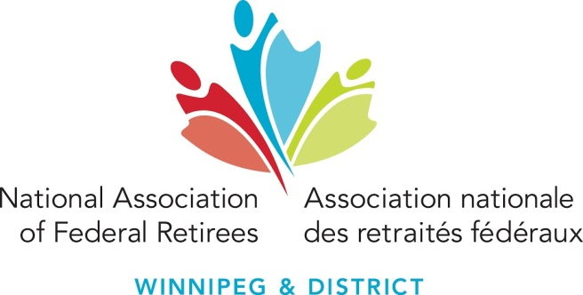 | National Association of Federal Retirees  Winnipeg & District Branch  National Website: www.federalretirees.ca  Branch Website: https://www.federalretirees.ca/en/Branches/Manitoba/Winnipeg-and-District  Branch E-mail: nafrwpg@mymts.net  Branch Mailing Address:  526-3336 Portage Avenue, Winnipeg, MB R3K 2H9  Phone: 204-989-2061
GENERAL MEETING: Wednesday, November 24, 2021
Business Meeting 1:00 p.m.
Meeting being held electronically through Zoom

AGENDA
1. Approval of Agenda
2. Introduction of new members (first time attending a meeting)
- Moment of silence for those no longer with us.
3. Review of Minutes from the April 14, 2021 General Meeting
4. President’s Report – Ceci O’Flaherty
5. Old Business
- Recap of April 2021 Annual General Meeting
- Recap of vacant volunteer positions
6. Reports
- Finance – Gwen Schentag
- District Director – Connie Kehler
- Branch Services Officer – Paula Nygaard
- Advocacy Programs Officer – Cynthia Foreman
Adjournment

2022 Schedule of Meetings

AGM – Tuesday, April 12, 2022

GM (2) – To be determined

