**BC07 DIRECTORS’ BIOS**

**GUY BIRD - President**

Guy was born in Montreal, and later met and married his wife Maureen from Sherbrooke, QC.

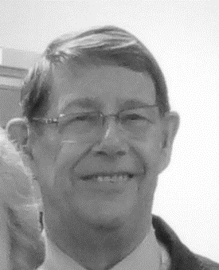He spent 13 years in the private sector (CIBC, Shell, and Consolidated Bathurst) in credit, finance, and foreign exchange, and then added 27 years with the Government of Canada in DIAND (Dept. of Indian Affairs and Northern Development, DFAIT (now Global Affairs) as the Counsellor Forest Sector at Canada’s Mission to the EU, Industry Canada and Natural Resources Canada in Economic and Industry Development, Trade development, promotion and policy.  During that time, he garnered three Merit Awards (one for the Federal Employees’ Charitable Campaign) and a Head of Public Service Award.

In “retirement”, he did international consulting mentoring professionals with the Government of Indonesia and 2 evaluations of a UN program for Least Developed Countries related to global trade.

Guy joined the Central Okanagan Branch of the Federal Retirees Association in 2002 and has served as Director, Vice President, and President.

He believes that service to members is number one and implemented the “make a difference” motto. He is proud of initiatives benefitting the community such as MEDWATCH, the “Christmas Family”, and assisting with the Salvation Army.

He founded the **President’s Forum** held during the Association’s Annual Meeting.

Guy has also served as President and Musical Director with the Kelowna Barbershop Harmony Chapter and implemented performing at seniors’ residences and assisting the Central Okanagan Child Development Association, Variety Club and The Salvation Army. He wrote, produced, and stage managed 4 musical shows including one at the National Arts Centre in Ottawa.

Guy is also involved with the Alzheimer’s Society and has chaired the committee for the annual Walk for Alzheimer.  He and wife Maureen are the 2020/21 Walk Honourees.

**JAN REDLICH - Vice President, Chair, Membership Team**

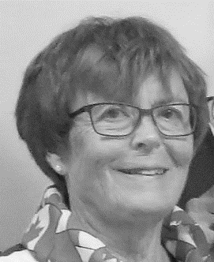Jan was raised on a farm in Saskatchewan.  After completing high school, she went on to attend the University in Saskatoon where she studied Education, and received her teaching degree.  Her first teaching position was at an elementary school in Kindersley SK.  She moved to Kelowna in 1970 and took a casual position with the Manpower Office (now Service Canada).  That position turned into a 25-year career with the Federal Government.

During that time, she was seconded to the Griesbach Base in Edmonton to help with the landing of Vietnamese refugees.  She heard and was touched by the stories of hardship these people endured, and saw the joy, and thankfulness they had for their new life in Canada.

In 1995, Jan took an early retirement from the Federal side, and joined the Ministry of Skills and training with the Provincial Government. She worked for Census Canada, and on several government contracts including employment skills and training for persons with disabilities, youth employment, a job club, and as a vocational rehabilitation counsellor.

She has shared her time and experience while volunteering for the Community Policing office, fund raising for minor sports groups, and with the Federal Retirees Association, Central Okanagan Branch.

Jan hopes that during her career, and while volunteering, she has made a difference in the lives of those she has touched.

**ETHEL ROBIDOUX - Director at Large**

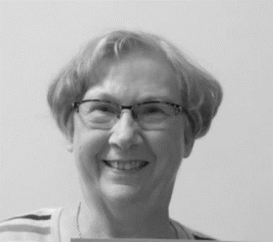Ethel began her career with the Federal government in August 1965 as a casual employee with the Unemployment Insurance Commission with the Sudbury office. Because she is bilingual, she was able to work directly with the public, assisting them with their forms, and answering general questions.

Two years later she moved to Kelowna with husband Norman and took a position in the Kelowna offices. Shortly after the new Federal Building opened on Queensway.

She was promoted several times, eventually to become an Officer/ Employment Counsellor, the position she held until her retirement in 1994.

Following retirement, she volunteered with ESL programs teaching immigrants English, and with the Multicultural Society assisting with work related programs and resume writing.

In 1995 when her Church, St Charles Garnier Parish, sponsored a family from Croatia, she worked with the family to help them settle in Kelowna, and Canada, with work and other related issues.

Ethel was presented with the NATIONAL PRESIDENT’S COMMENDATION AWARD. This Volunteerism Award is given to an Association member who has demonstrated an outstanding commitment to community service, through his or her volunteer activities **outside** of the Association.

Ethel joined NAFR in 1996 and has held the position of Director for many different committees, including Care and Concern, and often is found making visits to patients and residents in the Hospital and Care Homes.

She has been a long-term volunteer at Kelowna General Hospital in the Critical Care wards, is active in her Church, again with hospital and care home visits.

Care Home visits hold a special place in Ethel’s heart. She is happy to make a difference in the residents’ lives, putting a smile on their faces, and lifting their spirits with a chat or a card game.

**LAWRENCE CRABB - Director at Large**

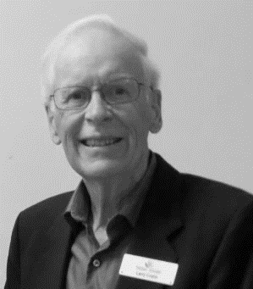Larry was born and raised in Saskatchewan and received a Degree in Civil Engineering from the University of Saskatchewan. He joined the RCAF and became a pilot and a Flying instructor serving in Moose Jaw and Portage La Prairie. He served in Cold Lake, AB training on fighter jets such as the Supersonic CF-104 (twice the speed of sound) before moving to the Canadian RCAF Base in West Germany in 1972.

While with NATO he became a Squadron commander of two Fighter Squadrons, interacted with other National air forces, and won the title as “Top Gun” in a 5 nations competition. Later he was seconded to the UN and sent to Egypt where he headed up the UN Air Force coordinating their activities as “Peacekeepers” in the Sinai desert, and providing logistical support to the UN Nations in the country. He spent several years with NATO Headquarters, living in Germany and the Netherlands. He led the procurement of NATO AWACs aircraft, and oversaw construction of the main operating base in Germany and other bases in Turkey, Greece, Italy, and Norway.

After 18 years serving Canada in Europe, he and Helen returned to Canada in 1994 and started a management consulting firm. They joined FSNA (NAFR) where he has held many positions including President, Vice President, and Director at Large.

Special projects Larry has been involved in include the implementation of the MEDWATCH program, and the “Learning Experience” initiatives.

**HELEN CRABB - Director, Care and Concern**

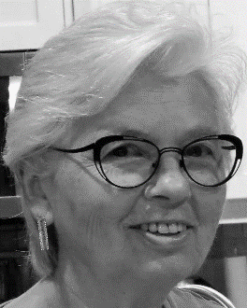 Helen was born and raised in central Saskatchewan. She married her childhood sweetheart, Larry Crabb and raised their two children while actively supporting Larry’s Air Force career. She and her family lived in many different communities in Canada as well as 18 years overseas in Germany and the Netherlands. She loved the opportunity to travel extensively, meet new people, and make lasting friendships.

She became involved in FSNA (NAFR) after moving to Kelowna in the mid 1990s. She believes in our motto of ‘Making a Difference’, conveying “Care and Concern”, and advocating on the behalf of Seniors.

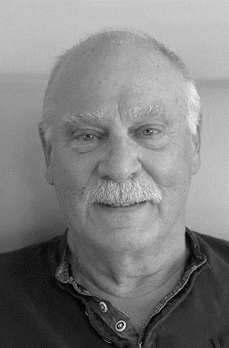**RICK INGELBEEN - Treasurer**

Rick began his career in 1965 when he joined the Airforce and underwent training as an Aircraft Crash Rescue Fire Fighter. After completion of his training, he was transferred to Winnipeg and served as a Fire Fighter at the Air Force Base at the Winnipeg International Airport. Their team responded to any and all emergencies involving military, commercial, or private aircraft that used the airport.

When Transport Canada took over the aircraft firefighting duties at the Winnipeg airport in 1968, he remained in the same fire hall where he continued to serve as a Fire Fighter and then a Fire Officer.

In 1988 Rick was promoted to Fire Captain and transferred to Vancouver international airport, followed by a quick transfer two years later to the Victoria International Airport as Fire Chief where he remained until his retirement in 1996.

He and his family relocated to Kelowna after his retirement and started his own business transporting recreation vehicles from manufacturers in the area to dealers across Canada and in the US.

Rick continues to be active in many associations, is a member of the Knights of Columbus, treasurer for the social committee for the community where he and his wife live, and the treasurer for the Central Okanagan Branch of the NAFR.

**BETH FRANK - Secretary**

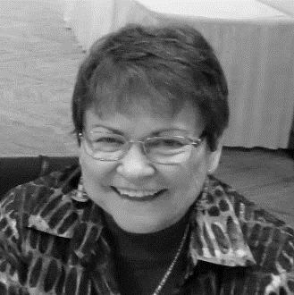Beth was born and raised in Winnipeg Manitoba, where she completed her primary and secondary education, and then attended the University of Manitoba to study Business Administration.

She held a long career (34 years) with the Federal Government with Transport Canada, Agriculture Canada, Veteran’s Affairs, and finally Health and Welfare (now Service Canada). In 1990 she transferred to Calgary.

The highlight of her career, and her most interesting aspect was her secondment to Electronics Data Systems (EDS) Canada in Ottawa to work on the Income Security Program redesign. She traveled across Canada as the Implementation Officer.

After retirement, she joined FSNA in Calgary before moving to Westbank in 1996 where she became an active member of the FSNA/NAFR Central Okanagan Branch, working on several board positions.

Beth was, and still is, an active member of the Sun Village community where she and her husband live. Since moving to Sun Village Beth has been on several committees, travels with the ‘Village’ folks locally and inter- nationally, and was President of their H.O.A. for a two-year term.

Beth enjoys volunteering for, and working with seniors and those organizations that advocate and support seniors’ issues.

**MAME MCCREA - Communications Director**

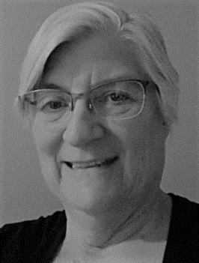Mame is a BC girl, born, raised, and lived most of her life in this beautiful province.

After high school, she followed her dream to attend nursing school, and after several years in that profession, followed by a marriage and children, she decided to leave shift work, and took a job with the Bank of Montreal, where she worked for 5 years.

In the late 70’s, her family relocated to Fort Nelson, BC where work and opportunities were plentiful.  At that time, Mame became a stay-at-home mom.

Once the children where school age, she began swimming lessons, and took it all the way to the top, becoming not only a life guard, but also a life guard trainer, and pool supervisor for a Child Development Centre.  She also became a Paramedic and worked on call for BC Ambulance during this time.

Mame also enrolled in the AHCOTE (Alaska Highway Consortium on Teacher Education). She received her Education teaching degree 3 years later, and then reenrolled in Athabasca University’s Masters of Business program.  During this time, she found herself the single parent to four children, but persisted none the less.  It was a long haul, but in 2000 she received her degree from Athabasca University, Alberta, and decided to leave the north.  But where to go?   Vancouver Island?  Kelowna? A coin toss made the decision.  Kelowna won!

Since being in Kelowna, Mame has designed and built two homes, worked as the General Manager of an Education Research Agency (SAEE), been the lead researcher on several projects, mostly for Indian and Northern Affairs, and then finished her career as the Manager of Health and Safety for Okanagan College.

Although Mame has never worked for the Federal Government, her now husband Paul is a retired RCMP officer, giving her the opportunity to become a member of NAFR.  She is part of the Communications committee for the Central Okanagan Branch.

In keeping with the motto of Make a Difference, Mame has offered her home, and heart to countless at-risk youth, many who continue to keep in contact with her as they move forward with their productive and sober lives.